**GENERIC ELECTIVE – 4**

**(OPEN SOURCE SOFTWARE)**

**Teacher: - Prof. Suparna Bora, Dept. of Computer Science & Engg.**

**ASSIGNMENT – 7.5**

**TOPIC- PYTHON PROGRAMMING**

**Prepared by- Name: - RAJDEEP DAS**

**Roll No. - 202151027**

**Course: - B.Sc. (H) Biotechnology,**

**2nd Semester**

**PROGRAM TO REVERSE A GIVEN STRING**

**Question: - Write code to reverse a string. Check if the new string is a palindrome. Next, insert space character after every letter in the new string.**

**Answer:-**

**Input:-**

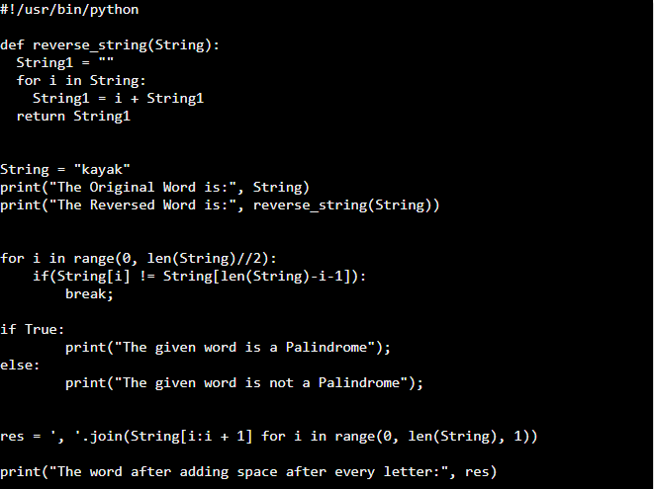

**Output**:-

